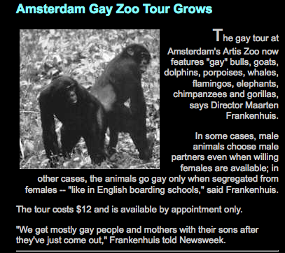

Web-event 2:
My goal was to construct an outline of a zoo tour that used some rough study materials from our class, some outside materials and mainly Joan Roughgarden’s Evolution’s Rainbow to open up discussion about homosexuality in animals. I wanted to speak to Roughgarden’s anger towards scientists who refuse to participate or engage in the discussion of animal homosexual behavior.

I started by googling “gay animal zoo tours” and a few similarly worded searches online and (among some weird things) really only found this small clipping to the right. http://gaytoday.com/garchive/world/030501wo.html

I decided that Amsterdam made sense as the international site for any likely gay zoo tour to exist having visited before and seen the liberal culture that openly welcomed the gay community. I figured I would fashion my zoo tour/study materials for the San Francisco zoo as California public schools made lgbtq history a mandatory recent inclusion within curriculums. http://www.nytimes.com/2011/07/15/us/15gay.html Since I am a “non-science” person, a distinction we, as a class, have used a lot through the course to identify ourselves in terms of comfort level with science related material, I would take this opportunity to think a little more radically about the possibilities of entangling the hard sciences and social sciences. I see this “slight” radicalism in my attempt to bring personal experience and personal perspective into conversation with animal experience and behavior. Animals cannot speak for themselves (and if they do it is in a language that humans can only second handedly try to evaluate) and others interpret their behavior. This is very similar to many lgbtq peoples’ experiences and that of author Joan Roughgarden herself (here I am referring the review of Evolution’s Rainbow as an authorial stunt?).

I also figured I my audience would be high school age students because it is an older age cohort that is more directly beginning to address questions and issues surrounding sexuality and because usually students take biology for the first time as freshmen in high school. I envisioned the Intern tour being led by a college age student who had a little more experience but was close enough in age to the students that the session felt more informal and discussion based. I primarily wanted to create an imagined space in which high school students could experience a vastly different type of fieldtrip that aligned their study of the biological with their understanding of the implications of the social.



San Francisco Zoo
Education Department

Guidelines for Student Intern Tour
Tour Topic: Uncovering the Cover-up: Gay Animals are in the Zoo too.
Age Range: High School; Grades 9-12
Starting Quote: “I also do not suggest that people are directly comparable to animals.... We make an error if we attribute too much human quality to animals, but we underestimate them if we think they're mechanical robots. I've tried to strike a balance here.” (pg. 4)
Beginning the tour with the above Roughgarden quote will place students in the right frame of mind to begin thinking about ways in which we can align ourselves alongside and in reference to animals and how to constructively and productively use the information and observations made from the tour to think about human sexuality and gender differences.
Special Observations/Human Interactions:
Whiptail Lesbian Lizards (Roughgarden, pg.128)
“But is the peaceful life of asexual whiptail lizards due only to close kinship and the absence of males? Or does peace also result from females forming air-bonds through same-sex courtship? An intriguing clue comes from the observation that the asexual females often share burrows, sleeping together in the same hole in the ground” (Roughgarden, pg. 131).
Creating a safe space within the classroom: students with be able to examine the lizards within a terrarium while local San Francisco Lesbian and asexual couples will be on-hand to answer any questions, comments or concerns about issues of identity.
Gay Male Swans (Roughgarden, pg.136)
“Gay swans may even raise offspring together as a couple. A female may temporarily associate with a male-male pair, mate with them, and leae her eggs with the,. The male couple then parents the eggs and is report to ber more successful than a male-female couple because together they access better nesting site and terrirotires, sharing the workload more equally than between-sex couples” (Roughgarden, pg. 136).
Creating a safe space within the classroom: students with be able to observe and take notes on the swan interactions, couplings and familial structures while local San Francisco gay male couples will be on-hand with their adoptive and biological children to answer any questions, comments or concerns about issues of kinship, rearing and reproduction.
Multi-Media Breakout Materials- at this point in the zoo visit students and teachers would be headed back to the education center to review some continuing education material

Isabella Rossellini’s Green Porno films clips:

Noah's Ark (SEDUCE ME Season 2)
http://www.youtube.com/watch?v=H108mSSov3A

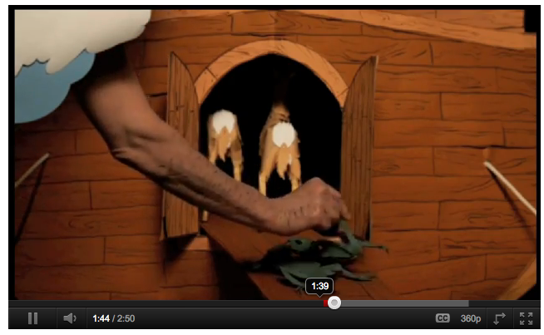
Introductory Quote:
“My guess is that hermaphrodism is more common in the world than species who maintain separate sexes in separate bodies.... The separate-sex/separate-body state is often viewed as "normal".... Alternatively, hermaphrodism may be viewed as the original norm, prompting us to ask what there is in mobile organism in the terrestrial environment that favors separate sexes in separate bodies.” (Roughgarden pg. 31)

This clip provides a secondary form of animation to Roughgarden’s examples of biological rainbows after observing animal behavior on our tour.

Watch the video and mull over how Roughgarden’s argument for the naturalness of biological diversity is inserted into a Western Christian religious tradition. How can the concepts, pairings or binaries of Rossellini’s animal …

-Hermaphrodite/Transvestite
-Transgender/Transsexual
-Polygamy/Monogamy
-Homosexual/Bisexual

change our ways of thinking about absolute order, naturalness as well as animal origins and creation?

Can we then use the Mimi Swartz, "Living the Good Lie." New York Times Magazine. June 16, 2011 to further probe the discussion of how animal homosexuality and the biological diversity of sexuality within animals may be a way to discuss homosexuality within people?

Discussion Questions:
What is the entanglement of science, religion and homosexuality in the zoo?
How can a zoo serve as a cross-special space of learning and inclusion?
Is using religious origin stories and religious metaphors a productive tool for reaching across cultural boundaries and constrictions?

Dolphin (SEDUCE ME Season 2)
http://www.youtube.com/watch?v=Z9FNhgdiieY

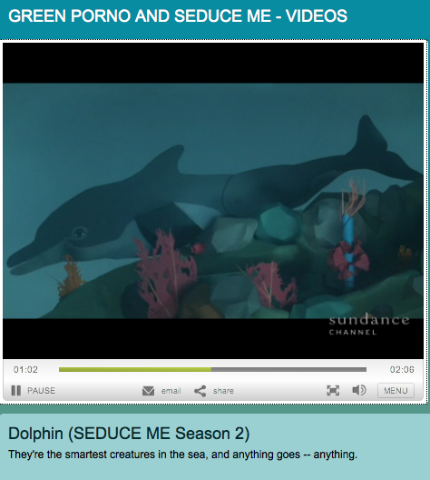

“The same-sex courtship is a part of forming and maintaining lifelong pair-bonds between male dolphins of the same age. They bond as adolescents, becoming constant companions and often traveling widely” (Roughgarden, pg. 141).

The Evolution of Sex: How do we define sexual interactions and behavior of animals as homosexual? What is the role of non-reproductive sex in animal and human behavior?

What is Courtship?
Leaping, chasing, playing, splashing, stroking, caressing, nuzzling

What is Sex?:
Masturbation, Genital Sound Wave Buzz, Oral Sex, Fin Sex, Blowhole sex

Discussion Questions:
Are these cross-special behaviors we have observed today?
Can we identify these activities as patterns of bonding and alliance formation?

Art Analysis Project:

“What stories should museums exhibit or nature films depict regarding same-sex courtship?” (Roughgarden, pg. 129)

Discussion Questions:
What is the role of the museum, zoo or classroom in providing objective information to students, teachers and individuals?
What is the difference between using the space in public and private institutions to talk about issues of biological sex and gender diversity?

Example piece: University of Oslo Natural History Museum’s first-ever museum exhibition dedicated to gay animals entitled, “Against Nature.”

Information provided at: http://news.bbc.co.uk/2/hi/6066606.stm

Information provided at: http://www.nhm.uio.no/besok oss/utstillinger/skiftende/againstnature/index-eng.html

Challenge for Students: If you were the curator at a fine arts museum or the zoologist at zoo would you create programming that continued to exemplify a biological rainbow of experience?
With a group of 4-5 students and a large sheet of paper come up with a mock-up poster for an event that you could co-host with Joan Roughgarden and tell us why you think you would accept or decline your invitation.

Ending Quote: "What won't work is stuffing our species into two small categories of gender and sexuality.... Social scientists... think diversity results from society producing difference among people who are biologically the same. I don't agree. The biology I know tells of endless variation, not of a few universals. This endless biological variation is always poking through social categories, spilling over the borders, fudging the edges." (pg. 396)

